2021 AIA/CES Conference Session Participation Form (C-1)  - Sessions listed on this form have been registered with the AIA/CES Records. Attendance will be recorded on your behalf by the CES Registered Provider. You may request a copy of this form for your files.  - You must include your AIA membership number to get credit. Check Yes for those activities you have completed.  - Member numbers that are missing or not legible will not be awarded credit.  - Partial credit/concurrent sessions marked “attended” are not awarded. Attendance is subject to verification.  - DO NOT SEND THIS FORM DIRECTLY TO CES RECORDS — RETURN TO CONFERENCE STAFF!  - Conference Provider will verify your attendance before forwarding this form to CES Records to record credit. | 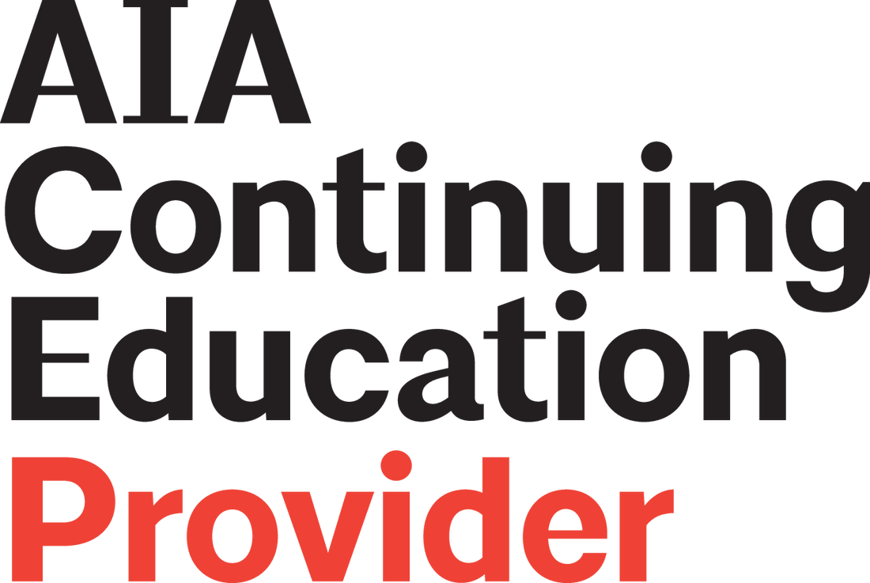

Participant Name:
AIA Member #: ________________________________
Request Certificate: Yes_____ No_____

Provider Name: Association for Learning Environments

Conference Number: 2021 LearningSCAPES

Provider Number: F118 Program Dates: October 14-17, 2021 Program Location: Denver, CO

Attended | Session # | Program Title | Credits | LU | LU/  HSW
Thursday, October 14, 2021 – 8:00 AM – 5:00 PM – School Tours

Yes No | LS2148 | Boulder Tour:  Halcyon Middle School / University Hill Elementary School / The University of Colorado Boulder Aerospace Engineering Sciences Building | 6 |  | Yes
Yes No | LS2149 | West Tour:  Warren Tech South Career and technical Education / Kendrick Lakes Elementary School | 4 | Yes
Yes No | LS2160 | North Tour:  FutureForward at Washington Square / Riverview PK-8 / Justice High School | 6 |  | Yes
Yes No | LS2151 | Central Tour:  Burwell Center for Career Achievement / Anderson Academic Commons / Cherry Creek Innovation Campus | 5 | Yes
Yes No | LS2152 | South Tour:  Castle View High School / Ford Elementary School / Newton Middle School | 5 |  | Yes
Yes No | LS2161 | East Tour:  Virginia Court Elementary School / Harmony Ridge P-8 School / East Middle School | 6 | Yes
Friday, October 15, 2021 – 8:30 AM – 11:00 AM – Opening General Session

Yes No | LS2153 | Education Reimagined: Four Ideas for the future we could start now | 1 | Yes
Friday, October 15, 2021 – 1:00 PM – 2:00 PM – Sessions – May choose only 1

Yes No | LS2133 | Social/Emotional Learning Through Curriculum and School Design | 1 |  | Yes
Yes No | LS2101 | “This School is for Us?”; Creating Change in Understanding Underserved Communities | 1 | Yes
Yes No | LS2105 | Built Form as a Public Health Intervention: How the Design of an Elementary School is Supporting the Physical, Mental, and Emotional Health of a Community | 1 |  | Yes
Yes No | LS2116 | Evolving Methods in Socially Responsive Architecture: The Future of Occupant Centered Design | 1 |  | Yes
Yes No | LS2145 | Virtual Engagement: When It Works and How to Get More Out of Remote Sessions with Stakeholders | 1 | Yes
Yes No | LS2136 | The Building Blocks of Transformative Change | 1 | Yes
Yes No | LS2154 | Student Health. Student Performance. Student Success. | 1 |  | Yes
Friday, October 15, 2021 – 2:15 PM – 3:15 PM – Sessions – May choose only 1

Yes No | LS2150 | Blurring the Lines 2.0: Agency, Personalization, and Lifelong Learning in the Future | 1 | Yes
Yes No | LS2107 | Comprehensive Approach to Safety and Well-being in Learning Environments | 1 |  | Yes
Yes No | LS2122 | Indigenous Schools – Past, Present, and Future | 1 |  | Yes
Yes No | LS2147 | Workplace 2.0 and What it Means for the Future of Learning Environments | 1 |  | Yes
Yes No | LS2110 | Designing for Mental and Emotional Health | 1 | Yes
Yes No | LS2140 | The Moon School: The First Galactic School! | 1 | Yes
Yes No | LS2128 | Designing Schools for Parental Engagement | 1 | Yes
Friday, October 15, 2021 – 3:30 PM – 4:30 PM – Sessions – May choose only 1

Yes No | LS2126 | Linking Educational Environments and Experiences for ProSocial Learning and Collaboration | 1 |  | Yes
Yes No | LS2132 | Shooting for the Moon: An optimistic process for the exploration of new possibilities for public education and the role of schools in our communities | 1 | Yes
Yes No | LS2120 | Harnessing Today’s Challenges & Opportunities to Influence the Future of American Education | 1 | Yes
Yes No | LS2139 | The Learning Playground – Adaptable Design Strategies for Equitable Access to Restorative Learning Environments | 1 |  | Yes
Yes No | LS2114 | Engineering the Future Leaders of our Community | 1 | Yes
Yes No | 2021GA-10 | Student Voice Informs Equitable Learning Space Design from A4LE SchoolsNEXT Design Competition | 1 | Yes
Yes No | LS2124 | Investing in Communities Through Placemaking and Play: Playful Learning Landscapes | 1 | Yes
Saturday, October 16, 2021 – 8:15 AM – 9:45 AM – Supersession

Yes No | LS2125 | JEDI Based Design | 1 | Yes
Saturday, October 16, 2021 – 10:00 AM – 11:00 AM – Sessions – May choose only 1

Yes No | LS2157 | A Tale of Three Projects: Storytelling as Adaptive Optimism in Educational Design | 1 | Yes
Yes No | LS2106 | Community School Models: A Path Forward for Education | 1 | Yes
Yes No | LS2108 | Comprehensive Learning Now and into the Future | 1 | Yes
Yes No | LS2129 | Restorative Environments for Wellness and Well-Being | 1 |  | Yes
Yes No | LS2144 | Valuing Student Voices as a Disruptive Force to Impact Design of Learning Spaces | 1 | Yes
Yes No | LS2130 | Resuscitating Educational Facilities for Innovative Learning and Environmental Stewardship | 1 |  | Yes
Yes No | LS2113 | Do Better Things ... not the Same Things Better | 1 | Yes
Saturday, October 16, 2021 – 11:15 AM – 12:15 PM – Sessions – May choose only 1

Yes No | LS2121 | How Collaboration Can Help Address Infrastructure Needs in Underserved Communities | 1 | Yes
Yes No | LS2137 | The Equity Project: Can a School in 2070 Fix Inequality and Truly Be Inclusive to All? | 1 |  | Yes
Yes No | LS2118 | For Better or Worse: The Five Stickiest Changes to Education Post COVID-19 | 1 | Yes
Yes No | 2021MWGL-01 | Raising the Bar on High Needs Specialized Education | 1 |  | Yes
Yes No | LS2119 | From Here to There: A Journey Towards Excellence and Equity in Philadelphia | 1 | Yes
Yes No | LS2155 | Interconnectedness – Towards Learning in 2070 | 1 | Yes
Yes No | LS2163 | The Collision of AGILE and MESSY: Supporting the Requirements of Authentic Learning | 1 | Yes
Yes No | LS2112 | Disruptive Resilience: Aligning Learning Styles and Teaching Pedagogies with a Biophilic Approach to 2070 School Buildings | 1 | Yes
Saturday, October 16, 2021 – 2:00 PM – 3:00 PM – Sessions – May choose only 1

Yes No | LS2109 | Dancing with the Yeti; how three resilient Iron Range communities in Northern Minnesota and two formerly competitive school districts remarkably came together and joined forces around a hopeful Next Century Vision for Learning to reinvigorate optimism | 1 | Yes
Yes No | LS2138 | The Learning Ecosystem of 2070 | 1 | Yes
Yes No | LS2123 | Intergenerational and Interconnected Community Learning: A Mixed Use Model | 1 | Yes
Yes No | LS2156 | I Belong. I’m Secure. I’m Inspired. A Conversation About the Future Classroom | 1 | Yes
Yes No | LS2162 | A Story of High-Performance Design Driven by Student Voice | 1 | Yes
Yes No | LS2131 | School 2070: Two Transformations | 1 | Yes
Yes No | LS2117 | Evolving the Paradigm: Community Based Learning in 2070 | 1 | Yes
Yes No | LS2142 | Through the Looking Glass: Reflections on the Future of Learning | 1 | Yes
Saturday, October 16, 2021 – 3:30 PM – 5:00 PM – Supersession

Yes No | LS2143 | Trauma-Informed Design | 1 |  | Yes
Sunday, October 17, 2021 – 8:00 AM – 9:00 AM– Supersession from Australia - Virtual

Yes No | LS2103 | After School | 1 | Yes
Sunday, October 17, 2021 – 9:20 AM – 10:30 AM – Supersession

Yes No | LS2127 | Place-Based Learning Shining Bright Beyond the Tyranny of Time and Space | 1 | Yes
 |  | Total Hours Attended:
I hereby certify that the above information is true and accurate to the best of my knowledge and that I have complied with the AIA Continuing Education Guidelines for the reported activities.

ATTENDEE SIGNATURE (Credit will not be awarded without signature.) DATE

Participants: Complete and return this form to: The registration desk, or send to:

Attn.: Edi Francesconi – A4LE – 11445 E Via Linda, Suite 2-440 – Scottsdale, AZ 85259 – Tel. (623) 285-8080 –
E-mail: edi@a4le.org

